**BOT GENERATED STOCK DETAILS BY RPA**

***D. Lohith Bhargav(TechE)***

***R. Nihanth Sai mani(TechE)***

***P. VamsiNadha(TechE)***

# Objective of your work

**Conclusion**

**Procedure, Model, Result**

**Introduction**

Bot Generated Stock Details Using Robotic Process Automation.

# Origin of your proposal

Humans can be used for creating new technology, but Bots can perform the repetitive tasks. As Stock market handling is complex and handled by humans till date. A Bot can replace human at this task.

**Tools & Methods**

# Tools

# Automation Anywhere Enterprise Edition

# Microsoft Money Application

# Working Excel

# Methods

# By using the Automation Anywhere Architecture and command library we can extract the unstructured and randomized data into a structured data and stored in a structured formatted application. Which helps in analysis of data and can be arranged in order.

# Figure 1

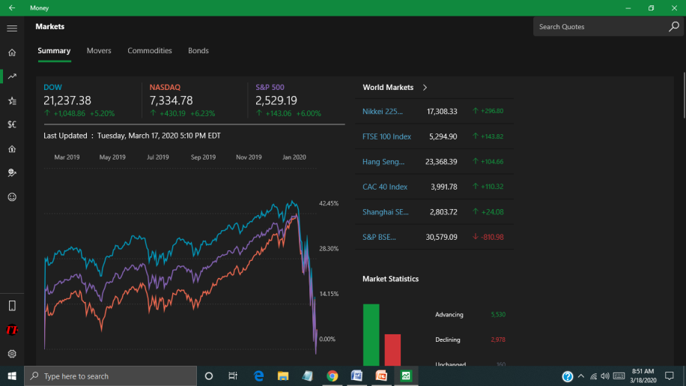

The execution of Bot is to go taskbar and click on search space have to type MONEY. So, the required application for the further processing will be selected and opened.

As it is internet related application we should wait for proper loading of application. These operations can be done with the help of Mouse Events and Keystrokes Events. The Stock Input excel will contain the company symbols w.r.t Money Application that input will read by bot and carry out the remaining process. Searching for the given input and extracting the required data by using OCR functions the fields are preselected by the bot creator and the extracted value are assigned to the variables.

***Note:*** *The Company Name should be of Microsoft Money Application Symbol name Like follows Facebook – FB, Google – GOOGL, Microsoft – MSFT, Apple – AAPL, ..etc. The Application should be Maximize & File Location also need to be proper for Execution of bot.*

**Figure 2**

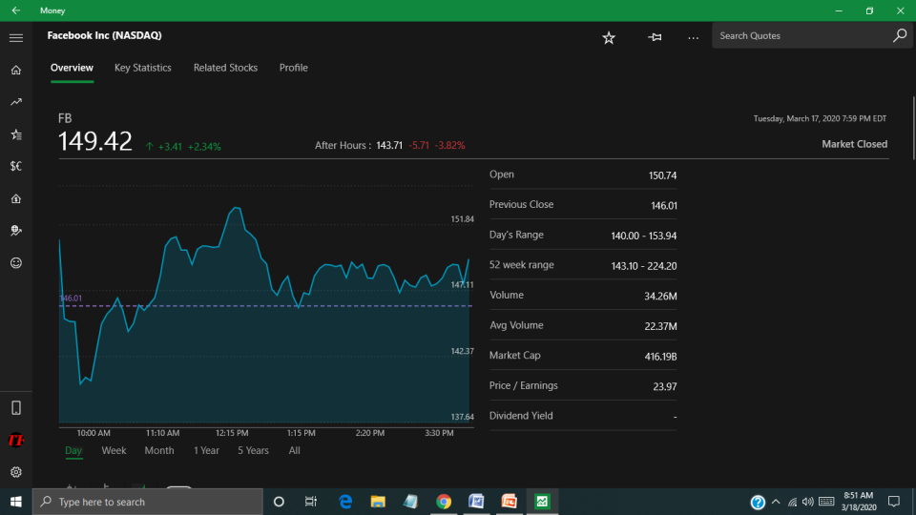

A Excel file with the company name have to be created by if the file is not there at the give destination. The Excel is to be opened and the data should be written in at the appropriate columns and the data should by saved automatically. These all tasks can be done with helps of the Excel commands in Command Library.

**Figure 3**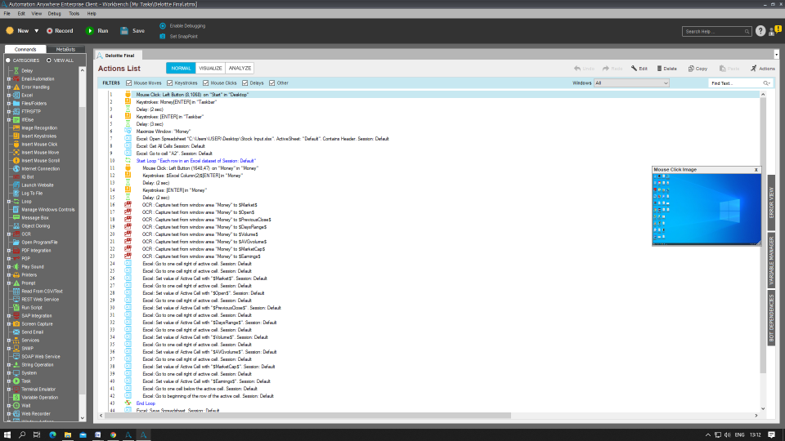

After the Execution, The Excel will be filled. Now, a pop-up window will appears which is asking to give a valid Email. To whom the Excel file to be sent for the analysis and other tasks.

## Figure 4

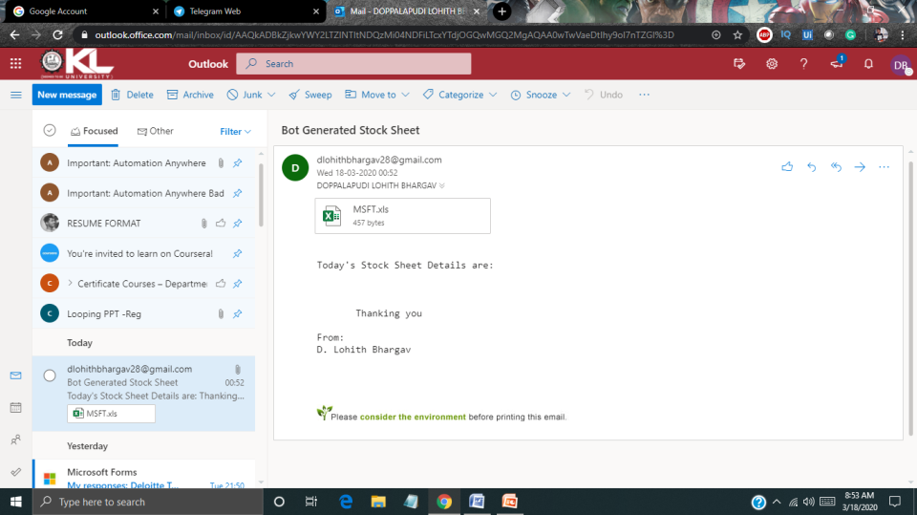

It will take few seconds to send a mail and that contains a attachment of excel file. So, the receiver can view the mail at any instance of time. And can download the Excel file.

## Figure 5

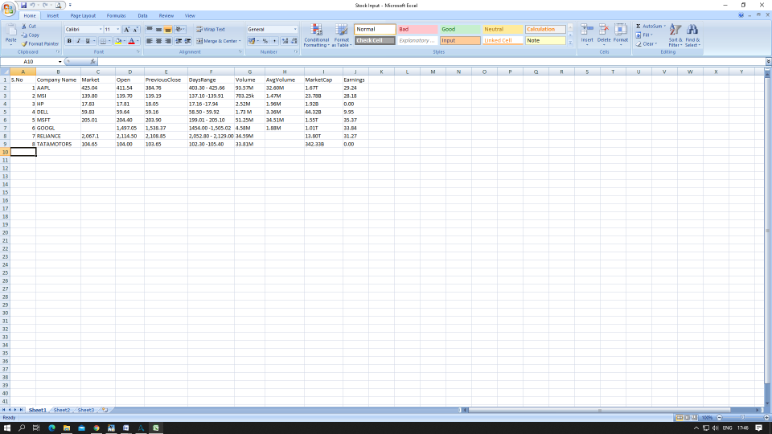

This is the Format of Output that will be generated by the bot. The Excel can be viewed by the Respective Officer.

# In this method we can achieve the bot generated stock details and which helps the company to reduce the humans work, time and accurate when compared to the humans. The ROI(Return On Investments) of company will raise and operations also done very fast.Discussion/Conclusion

We conclude that this bot helps in saving the humans work, time in performing repetitive tasks and company investments.

# Limitations

If Bot detects any change in application format, resolutions and mail properties it aborts the operation and don’t work.

# Future Direction

This Bot helps in many industry to keep a track on stock markets. And we can implements this RPA in other real time projects also. Like booking system, online shopping, chat bots. Etc..

**References and Affiliations**

## References

<https://www.automationanywhere.com/>

Microsoft Money Application.

## Acknowledgements

Thanks to Deloitte for providing a platform Technoutsav 3.0 to showcase our ideas and projects.